**PF LAB 5; 4 TASKS**

Name: Ammar Ahmed Farooqui

Roll Number: 25k-0728

*TASK # 1:*

**CODE:**

#include<stdio.h>

int main()

{

int a, b;

//Equation= a+b*(a-b)/2

printf("Enter the first Number:\t");

scanf("%d", &a);

printf("Enter the second Number:\t");

scanf("%d", &b);

printf("\nThe first statement is (a-b):\t%d",a-b);

printf("\nThe second statement is (a-b)/2:\t%d", a-b/2);

printf("\nThe third statement is b*(a-b)/2:\t%d", b*(a-b)/2);

printf("\nThe fourth statement is a+b*(a-b)/2:\t%d", a+b*(a-b)/2);

return 0;

}

**OUTPUT:**

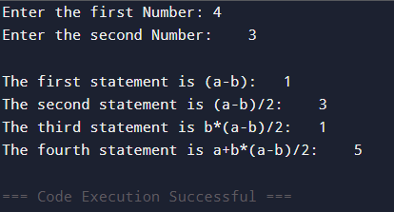

*TASK # 2:*

**CODE:**

int main()

{

int x, y, op1, op2, op3;

printf("Enter the Number, X:\t");

scanf("%d", &x);

printf("Enter the Number, Y:\t");

scanf("%d", &y);

op1=(x>5) && (y<10);

op2=(x==10) || (y==5);

op3=!(x==y);

printf("\nThe result of first condition is:\t%d", op1);

printf("\nThe result of second condition is:\t%d", op2);

printf("\nThe result of third condition is:\t%d", op3);

return 0;

}

**OUTPUT:**

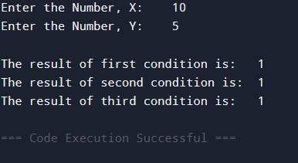

*TASK # 3:*

**CODE:**

#include<stdio.h>

#include<math.h>

int main()

{

int num, opr;

printf("Enter the Number:\t");

scanf("%d", &num);

opr=sqrt(num);

printf("\nThe square root of the number is:\t%d",opr);

return 0;

}

**OUTPUT:**

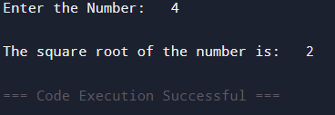

*TASK # 4:*

**CODE:**

#include<stdio.h>

int main(){

int m, n, opr;

printf("Enter the Number, m:\t");

scanf("%d", &m);

printf("Enter the Number, n:\t");

scanf("%d", &n);

opr=m>n?printf("\n%d is greater than %d",m,n):printf("\n%d is greater than %d",n,m);

return 0;

}

**OUTPUT:**

